**Nexus**

*Made by Manzil Ahsan Mahim*

[*manzilahsan8105@gmail.com*](mailto:manzilahsan8105@gmail.com)

**INTRODUCTION**

Nexus is an innovative forum system designed to enhance user engagement, streamline content management, and build a thriving online community where people can share knowledge and benefit from each other. Let's dive into the details.

**PROBLEM STATEMENT**

Modern forums face significant challenges, including inefficient content discovery, limited user engagement, and ineffective moderation. These shortcomings directly impact user retention and discourage meaningful interactions, creating a fragmented user experience. This project aims to address these issues by delivering a dynamic, feature-rich platform designed to foster collaboration, streamline knowledge sharing, and enhance the overall user experience.

The cornerstone of the problem statement lies in tackling a pressing issue in today’s digital landscape: the overwhelming distraction caused by information overload. In a world inundated with content—primarily from social media—our brains are constantly bombarded with notifications, updates, and irrelevant distractions. This relentless flood of information has fundamentally altered our ability to focus, leading to procrastination and inefficiency, particularly during deep work sessions.

Current forum-based platforms like Reddit and X often exacerbate these issues by incorporating features that encourage aimless scrolling, exposure to irrelevant content, and advertisements that further divert users’ attention. While popular, these platforms fail to create an environment conducive to focused learning or meaningful knowledge exchange.

In stark contrast, this proposed open-source platform is designed with a singular focus: knowledge sharing without distractions. The site will exclude irrelevant advertisements, irrelevant content, and features that encourage procrastination. By ensuring that all content is exclusively knowledge-related, users can immerse themselves in productive discussions and maintain focus on their goals.

This emphasis on distraction-free engagement sets our platform apart. It is tailored to meet the needs of users who value deep focus and meaningful interaction, enabling them to achieve their objectives without succumbing to the pitfalls of the modern internet.

#### **Features:**

1. Authentication:
   * Log in / Log out.
   * Sign up via email with password protection.
   * Different role-based accounts (regular users and admins).
2. Posting and Engagement:
   * Posting features with Like/Dislike options.
   * Most liked posts appear more prominently in user feeds.
   * Users can bookmark posts for quick access in their profiles.
   * Advanced comment sections for detailed discussions under questions.
3. Activity Feed:
   * Real-time feed showing new questions, answers, or trending discussions.
4. Content Management:
   * Featured questions based on upvotes or admin selection.
   * Trending tags highlighting active discussions.
   * Tags categorizing posts for efficient searching.
   * A searchable tag library is used to filter questions by tags.
5. Content Recommendations:
   * Related questions are suggested based on tags or user search history.
6. Question Status Management:
   * Mark questions as "Answered," "Unanswered," or "Closed."
   * Allow question posters to accept an answer, signaling it as the most helpful.
7. Reputation and Privileges:
   * Users earn points for contributions:
     + Upvotes on their answers or questions.
     + Accepted answers by question posters.
   * A higher reputation unlocks privileges like moderating the forum (if the user opts for a moderator or admin role).
8. Moderation and Reporting:
   * Report option for inappropriate content.
   * Moderators can remove reported posts or ban users as necessary.
   * Audit logs ensure transparency in moderation actions.
9. Chat Features:
   * User-to-user chat box.
   * Group chat box for collaborative discussions.
10. API Integration: (if possible)
    * API for third-party apps or developers to fetch or post forum data programmatically

**Tech Stack:**

MySQL

PHP

HTML and Tailwind CSS

**Benchmark Analysis:**

Existing platforms like Reddit, Quora, and Stack Overflow were studied. While these platforms excel in many and certain areas, such as upvoting systems or tagging, they lack a comprehensive combination of features, particularly in real-time engagement and role-based customization. Our forum system bridges these gaps by integrating these strengths into a cohesive solution. Let me give you an example:

Reddit

Strengths:

Dynamic Community Engagement: Reddit thrives on its subreddit system, allowing users to engage in niche communities based on their interests.

Upvote/Downvote System ensures that the most relevant and useful content surfaces at the top.

Moderation Tools: Subreddit moderators can enforce rules effectively, maintaining content quality and community standards.

Weaknesses:

Content Discovery:

While subreddits offer organization, discovering relevant content across subreddits is challenging due to a lack of robust recommendations.

Limited User Roles:

Users are either regular members or moderators, with no intermediate roles that reward positive contributions or expertise.

Comment Threads:

Discussions in long threads can become unwieldy and difficult to follow.

How We Address This:

Our forum system incorporates robust tag-based filtering and personalized content recommendations to make content discovery seamless. Additionally, we introduce a reputation-based privilege system, allowing users to unlock roles and features as they contribute positively. It also lets other low-rank users trust answers based on the contributions of high-rank users.

**ER DIAGRAM**

The following ERD outlines the relationships and connections among entities in our forum system. It demonstrates the logical structure of the database while highlighting key relationships, primary keys, and foreign keys.

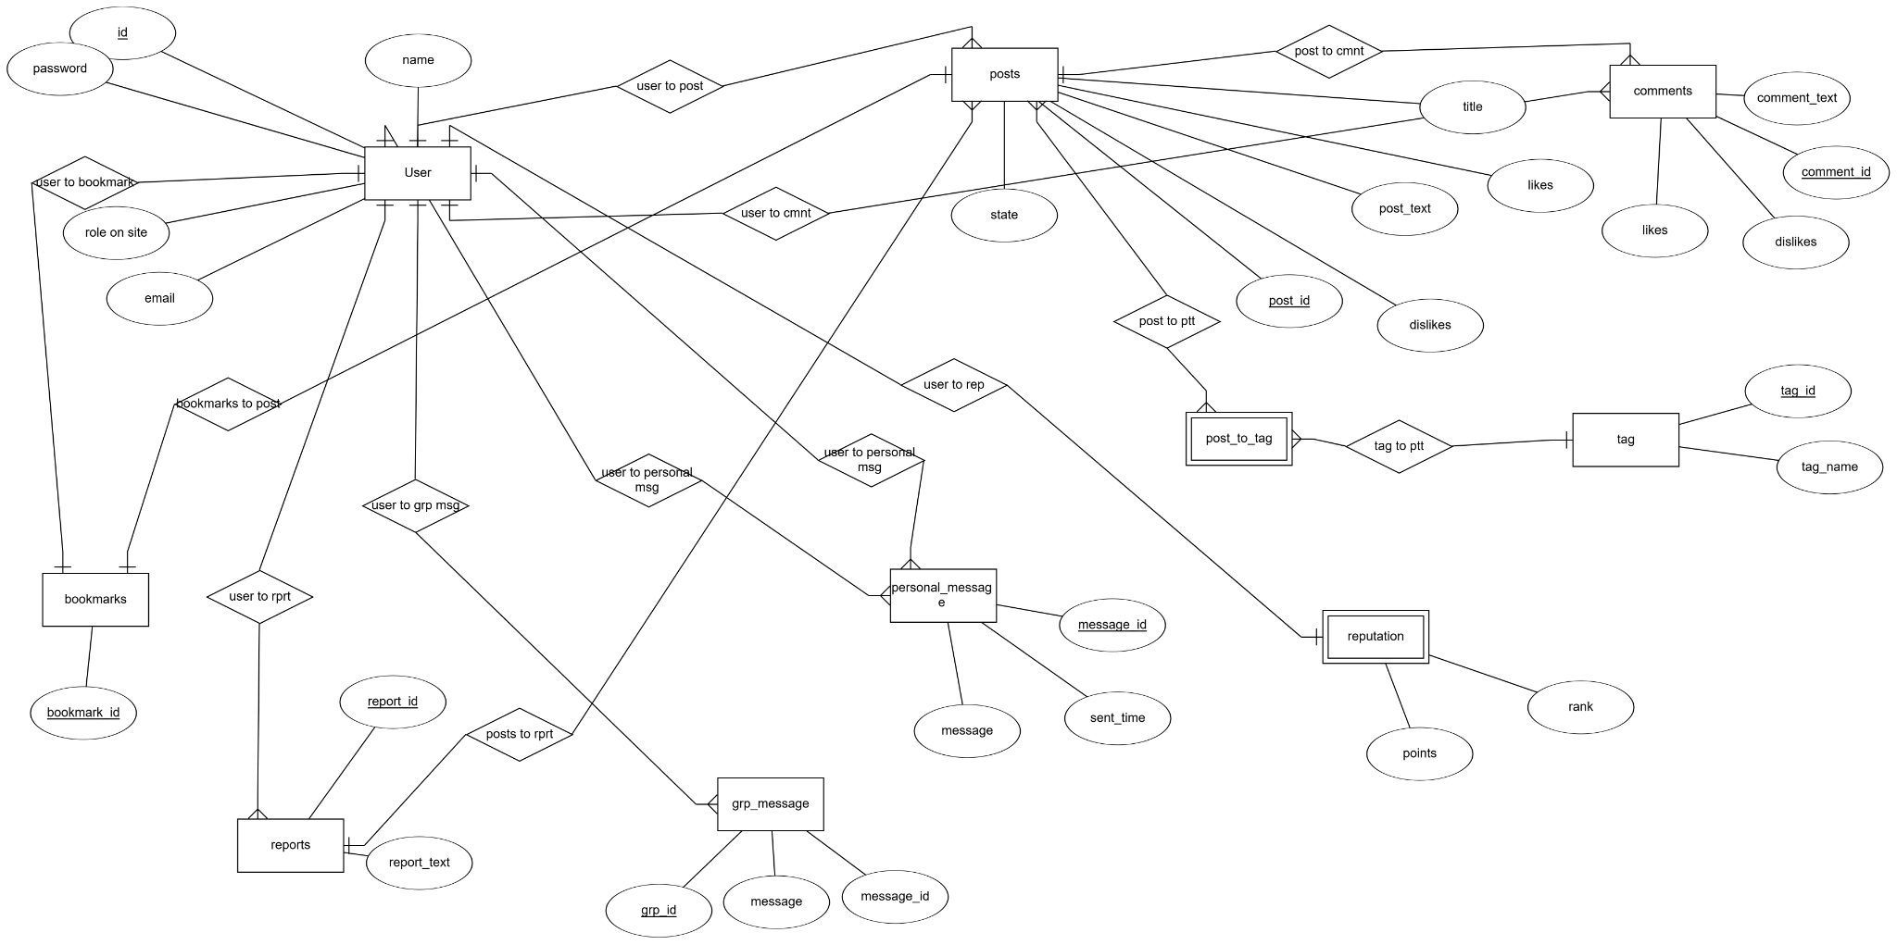

**SCHEMA**

The database schema presented below represents all possible connections and outlines every entity from the earlier ER diagram. Like before, this schema is designed to include all types of relationships, utilizing primary and foreign keys to ensure an optimized database management system.

